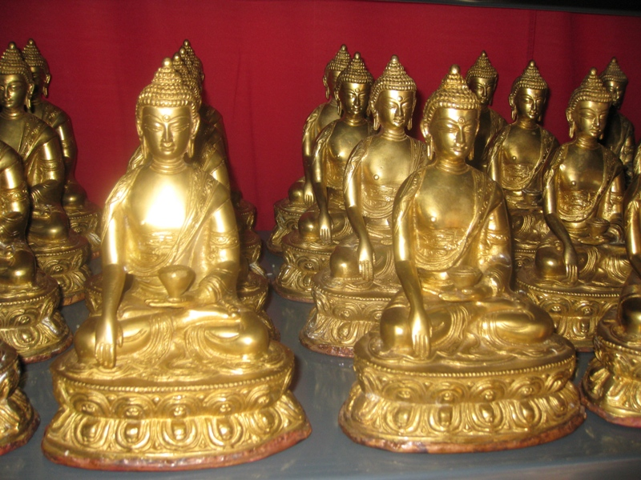

1008 Shakya Muni Buddha

Contact Address:

Tana Dharma Society
No. 5, Jalan SS17/2L, Subang Jaya
47500 Petaling Jaya, Selangor.
Tel: 03-5632 6103 Fax: 03-5632 3995

All cheques should be crossed and made payable to:

TANA DHARMA SOCIETY

Account No.: 045 01 003 887
Hong Leong Bank Berhad
Subang Jaya Branch

In order to propagate the Buddha Dharma and to benefit all 1008 sentient beings, we have 1008 Buddha Shakyamuni Statue (8 inches) in the main Shrine Hall of Tana Monastery (in India). The sponsorship for each statue is RM 688.00.

We humbly seek your most generous support in this project. Your kind donation would give the Sangha a more conducive environment for them to learn and practise the Buddha Dharma.

Name: _______________________________________

Address:_____________________________________

____________________________________________

Contact Nos.: (H/P)______ ______________________

(H): ___________________ (O) __________________

Fax: ___________________

No. of statues sponsored: ____________

BENEFITS OF SPONSORING BUDDHA STATUES

The Buddha said: “In future when sentient beings make offering of Buddha statues, the amount of merits is equivalent to making offering to me”. Offerings and prostrations made to the Buddha Statues are the same as being done to the Buddha. They become immediate cause of enlightment alleviate sufferings, induce happiness and bring about a good rebirth in many lifetimes.

One gains the merits as long as the Buddha statue lasts and would also gain merits whenever others pray to it. Therefore, those who contribute to the virtue of building the Precious Buddha Statues would receive immeasurable merits and bonding with the Buddha.

